Exclusive Plaza (lower level),
Rt. 9 North and Union Hill Road Intersection,
Marlboro, NJ 07776
Telephone: 732-617-8077
Fax: 732-617-8078

E-mail:loungecafe@aol.com

Our Hours:

Mon: 12PM - 6PM

Tue-Thu: 12PM – midnight

Fri-Sat: 12PAM-1AM
Sun: special events and parties
Contemporary European Style Cafe
and Crepe House
CONCERT
In The Lounge Cafe
November 16, 6:00 PM.

Александр Алабин, гитара, голос
Александр Никитин, гитара, голос
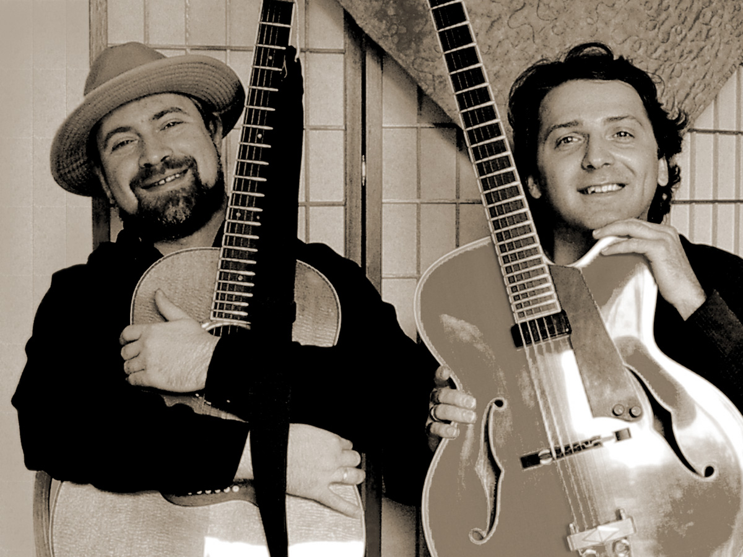
The State Department has discovered jazz enriches folks like nothing ever has.
Like when they feel that jazzy rhythm they know we're really with'em.
That's what we call

Cultural Exchange
американский и наш джаз
французский шансон и бразильская босса
цыганский городской романс

For information and tickets, please call (732) 617-8077

