wednesday, July 14 at 7 PM
LIVE IN CONCERT from New York
guitarist and composer

ERIK SOOTES

Erik Sootes is a virtuoso solo guitarist and composer. He holds a PhD in music theory and composition from the St. Petersburg Conservatory of Music. Erik writes and skillfully performs guitar music in an astonishing variety of genres: classical, flamenco, jazz, fusion, folk, pop, and so on. To date he has released 11 original albums. For more information please visit his web site www.sootes.com
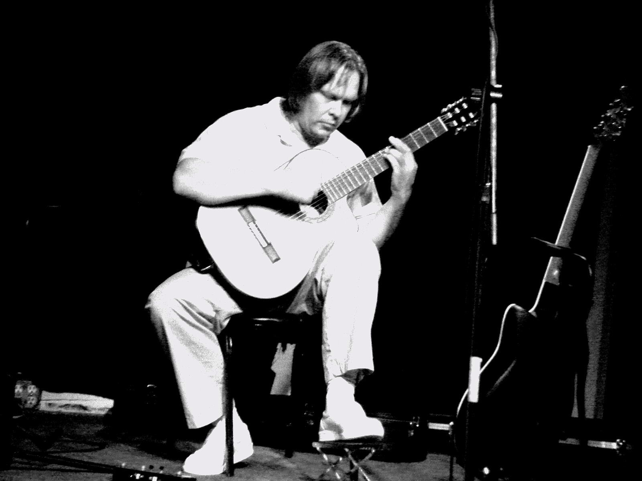
The music of Erik Sootes is used in movies and in radio shows. People of different ages and backgrounds who have been to Erik's concerts call his performances magical and unforgettable.

THE CONCERT WILL TAKE PLACE

on Wednesday, JULY 14 at 7 P.M.
at Park Place Club House

5600 South 1580 East, Salt Lake City, UT, 84121
Tickets – $15 ($10 for students and seniors)

FOR MORE DETAILS PLESE CALL NATASHA AT (801) 699-2549, OR E-MAIL to:NATASHALIBERMAN@HOTMAIL.COM

